

Politecnico di Milano

2015-2016

Software Engineering 2

Code Inspection

version 1.0

Author: Nenad Petrovic

22nd November 2015

Contents

1 Introduction 3

1.1 Purpose 3

1.2 Scope and document overview 3

1.3 Definitions, acronyms, abbreviations 4

1.4 Reference documents 7

2 Architectural design 8

2.1 Overview 8

2.2 High level components and their interaction 9

2.3 Component view 11

2.4 Deployment view 14

2.5 Runtime view 17

2.6 Component interfaces 25

2.7 Selected Architectural Styles and Patterns 40

3 Algorithm desgin 46

3.1 Scheduling algorithm 46

3.2 Taxi zone determination 48

3.3 Cost estimation algorithm 52

4 User interface design 54

5 Requirements traceability 66

6 Database design 68

7 Software and tools used 69

7.1 Hours of works 70

8 References 70

# Assigned classes and methods

In this assignment, a part GlassFish Server source code is assigned and is going to be inspected according to the specified checklist. The following methods are assigned for code inspection:

Name: processMaybeNullOperation( List stack , StringBuffer result )

Start Line:

714

End Line:

789

Location:

appserver/persistence/cmp/support-sqlstore/src/main/java/com/sun/jdo/spi/persistence/support/sqlstore/sql/generator/Statement.java

Name: processNullOperation( int opCode , List stack , StringBuffer result )

Start Line:

791

End Line:

822

Location:

appserver/persistence/cmp/support-sqlstore/src/main/java/com/sun/jdo/spi/persistence/support/sqlstore/sql/generator/Statement.java

All of the assigned methods, as it can be seen, belong to the same .java file – „Statement.java“. This file contains one public abstract class:

public abstract class Statement

The corresponding package is:

package com.sun.jdo.spi.persistence.support.sqlstore.sql.generator;

A package is a named collection of classes (and possibly subpackages). Packages serve to group related classes and define a namespace for the classes they contain.

# List of issues found by applying the checklist

In this chapter, the relevant checklist is going to be presented, together with the results of the inspection for each part of the checklist. It is going to be stated if the issue exists and the number that belongs to the corresponding code line where the issue is found. If issue exists, it is going to be discussed. If there is no issue, it is going to be stated that there is no issue, but also potential issues are going to be discussed even if they not clearly exist. Also, it is going to be stated if such case doesn’t exist in assigned method/class.

***Code inspection checklist and issues***

## Naming Conventions

1. All class names, interface names, method names, class variables, method variables, and constants used should have meaningful names and do what the name suggests.

No issues.

1. If one-character variables are used, they are used only for temporary “throwaway” variables, such as those used in for loops.

No issues.

There is only one temporary one-character variable. It is not used as a loop counter or inside loop, but is throwaway variable that only „lives“ inside one if statement, so it can’t considered as a real issue.

In what follows, a part of the code which includes this case is going to be extracted.

Starting from line number 740, we have:

if (value instanceof String) {

String v = (String) value;

if (v.length() == 0) {

stack.add(fieldNode);

stack.add(new ConstraintOperation(ActionDesc.OP_NULL));

} else {

stack.add(valueNode);

stack.add(fieldNode);

stack.add(new ConstraintOperation(ActionDesc.OP_EQ));

}

}

1. Class names are nouns, in mixed case, with the first letter of each word in capitalized. Examples: class Raster; class ImageSprite;

No issues.

There is only one assigned class (public abstract class), and it is named „Statement“, so there are no issues with this.

1. Interface names should be capitalized like classes.

No issues.

There is no any interface defined in this file.

1. Method names should be verbs, with the first letter of each addition word capitalized. Examples: getBackground(); computeTemperature().

Issues found.

As it can be seen below, the methods starting from lines:

925,1002,1104 and 1135 don’t start with verbs (they start with nouns and adjectives), so this could be an issue, according to the checklist.

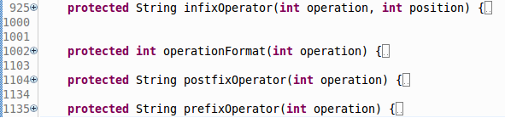

1. Class variables, also called attributes, are mixed case, but might begin with an underscore (‘_’) followed by a lowercase first letter. All the remaining words in the variable name have their first letter capitalized. Examples: _windowHeight, timeSeriesData.

No issues.

1. Constants are declared using all uppercase with words separated by an underscore. Examples: MIN_WIDTH; MAX_HEIGHT;

# No issues.

Constants are all upercase and spearated by an underscore, for example:

protected static final int OP_PREFIX_MASK = 0x001;

# Indention

1. Three or four spaces are used for indentation and done so consistently

No issues.

Four spaces are used consistently.

1. No tabs are used to indent

No issues.

Tabs are only used in some of the comments but not for indentation.

# Braces

1. Consistent bracing style is used, either the preferred “Allman” style (first brace goes underneath the opening block) or the “Kernighan and Ritchie” style (first brace is on the same line of the instruction that opens the new block).

No issues.

Allman style (left) , Keringhan and Ritchie style (right) are illustrated below.

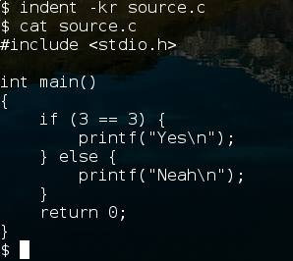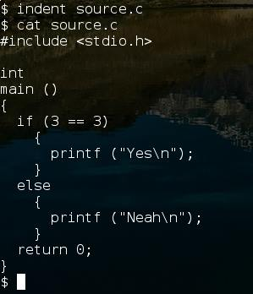

“Kernighan and Ritchie” style is used in this code and is used consistently in this code, so there are no issues related to bracing.

1. All if, while, do-while, try-catch, and for statements that have only one statement to execute are surrounded by curly braces. Example:

Avoid this:

if ( condition ) doThis();

Instead do this:

if ( condition )

{

doThis();

}

No issues. The code satisfies this rule and is consistent.

# File Organization

1. Blank lines and optional comments are used to separate sections (beginning comments, package/import statements, class/interface declarations which include class variable/attributes declarations, constructors, and methods).
2. Where practical, line length does not exceed 80 characters.

No real issues related to this one.

There are lines that exceed 80 characters (lines numbered by 92,806, 815, 820, 824, for example), but it is not so practical to break these lines.

In fact, it could be done, but is not a real issue and depends only on coder’s decision.

For example:

String str = (opCode == ActionDesc.OP_NULL) ? vendorType.getIsNull() : vendorType.getIsNotNull();

This line could be broken like:

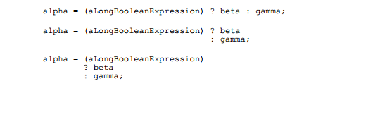

1. When line length must exceed 80 characters, it does NOT exceed 120 characters.

No issues.

There is no any line that exceeds 120 characters in this file.

## Wrapping Lines

1. Line break occurs after a comma or an operator.

No issues.

Line breaks occur after comma or an operator (=, &&, for example) in the assigned code.

1. Higher-level breaks are used.

When an expression will not fit on a single line, break it according to these general principles:

* Break after a comma.
* Break before an operator.
* Prefer higher-level breaks to lower-level breaks.
* Align the new line with the beginning of the expression at the same level on the previous line.
* If the above rules lead to confusing code or to code that’s squished up against the right margin, just indent 8 spaces instead.

In what follows, two examples are going to be presented:

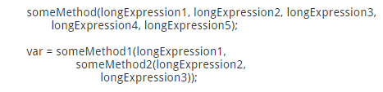

The two examples apply breaking to an arithmetic expression. The first is   
preferred, since the break occurs outside the parenthesized expression,   
which is at a higher level.

For example, in lines 800 and 801:



This break is not after a comma, nor before the operator.

1. A new statement is aligned with the beginning of the expression at the same level as the previous line.

Taking a look at stated rules again:

* Align the new line with the beginning of the expression at the same level on the previous line.
* If the above rules lead to confusing code or to code that’s squished up against the right margin, just indent 8 spaces instead.

No issues.

Let’s take a look at previous example:



It can be seen that in lines 800 and 801 the second rule is used and line is aligned by 8 spaces, so there is no issue, because antoher rule is used.

## Comments

1. Comments are used to adequately explain what the class, interface, methods, and blocks of code are doing.

No issues.

There are comments that are used to make some things that are not so obvious more clear (constant values and some other values, as exception numbers, for example), so they are not only limited to what blocks are doing, but also could stand for some further explanations .

1. Commented out code contains a reason for being commented out and a date it can be removed from the source file if determined it is no longer needed.

There is an issue related to previously mentioned part of the code (which is not a part of the assigned methods, by the way).

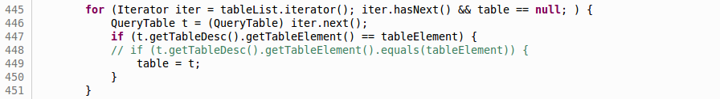

Considering the line 448, we can see that there is no reason mentioned why it is commented, nor the date when it can be removed.

## Java Source Files

1. Each Java source file contains a single public class or interface.

No issues.

There is only a single public class inside this java source file (Statement.java).

1. The public class is the first class or interface in the file.

No issues.

1. Check that the external program interfaces are implemented consistently with what is described in the javadoc.

No issues.

1. Check that the javadoc is complete (i.e., it covers all classes and files part of the set of classes assigned to you).

No issues.

## Package and Import Statements

24. If any package statements are needed, they should be the first noncomment statements. Import statements follow.

## Class and Interface Declarations

1. The class or interface declarations shall be in the following order:
   1. class/interface documentation comment
   2. class or interface statement
   3. class/interface implementation comment, if necessary
   4. class (static) variables
      1. first public class variables
      2. next protected class variables
      3. next package level (no access modifier)
      4. last private class variables
   5. instance variables
      1. first public instance variables
      2. next protected instance variables
      3. next package level (no access modifier)
      4. last private instance variables
   6. constructors
   7. methods
2. Methods are grouped by functionality rather than by scope or accessibility.
3. Check that the code is free of duplicates, long methods, big classes, breaking encapsulation, as well as if coupling and cohesion are adequate.

## Initialization and Declarations

1. Check that variables and class members are of the correct type. Check that they have the right visibility (public/private/protected)
2. Check that variables are declared in the proper scope
3. Check that constructors are called when a new object is desired
4. Check that all object references are initialized before use
5. Variables are initialized where they are declared, unless dependent upon a computation
6. Declarations appear at the beginning of blocks (A block is any code surrounded by curly braces “{“ and “}” ). The exception is a variable can be declared in a ‘for’ loop.

## Method Calls

1. Check that parameters are presented in the correct order

No issues, parameters are called in correct order.

1. Check that the correct method is being called, or should it be a different method with a similar name

No issues.

1. Check that method returned values are used properly

No issues.

## Arrays

1. Check that there are no off-by-one errors in array indexing (that is, all required array elements are correctly accessed through the index)
2. Check that all array (or other collection) indexes have been prevented from going out-of-bounds
3. Check that constructors are called when a new array item is desired

## Object Comparison

40. Check that all objects (including Strings) are compared with "equals" and not with "=="

No issues inside the assigned methods, but there could be an issue in this class, in line number 447.



TableElements are compared using == and standard operators cannot be overloaded in java, so this could be an issue.

## Output Format

1. Check that displayed output is free of spelling and grammatical errors
2. Check that error messages are comprehensive and provide guidance as to how to correct the problem
3. Check that the output is formatted correctly in terms of line stepping and spacing

No issues related to 41,42 and 43.

## Computation, Comparisons and Assignments

1. Check that the implementation avoids “brutish programming: (see [http://users.csc.calpoly.edu/~jdalbey/SWE/CodeSmells/bonehead.html)](http://users.csc.calpoly.edu/~jdalbey/SWE/CodeSmells/bonehead.html)

The implementation avoids brutish programming and there are no issues.

1. Check order of computation/evaluation, operator precedence and parenthesizing
2. Check the liberal use of parenthesis is used to avoid operator precedence problems.
3. Check that all denominators of a division are prevented from being zero
4. Check that integer arithmetic, especially division, are used appropriately to avoid causing unexpected truncation/rounding

No issues related to 45,46,47 and 48, because the methods don’t do such computations where some of the cases could happen.

1. Check that the comparison and Boolean operators are correct

No issues.

1. Check throw-catch expressions, and check that the error condition is actually legitimate
2. Check that the code is free of any implicit type conversions

No issues.

The conversions are explicit.

## Exceptions

1. Check that the relevant exceptions are caught
2. Check that the appropriate action are taken for each catch block

## Flow of Control

1. In a switch statement, check that all cases are addressed by break or return

No issues.

Assigned methods don’t have switch statements, and other switch statements, outside these methods are properly addressed by break.

1. Check that all switch statements have a default branch

No issues.

Assigned methods don’t have switch statements. Other switch statements, outside these methods satisfy this condition, so there are no issues.

1. Check that all loops are correctly formed, with the appropriate initialization, increment and termination expressions

No issues.

All loops are correctly formed and there are no loops directly related to assigned methods (but there are in this class, in general).

## Files

1. Check that all files are properly declared and opened
2. Check that all files are closed properly, even in the case of an error
3. Check that EOF conditions are detected and handled correctly
4. Check that all file exceptions are caught and dealt with accordingly

There are no issues related to 57,58,59 and 60, because the assigned methods don’t deal with files directly (and this class, in general).